CHAPTER 1 INTRODUCTION

1.1 Background and Motivation
Delhi adds roughly half a million new residents every year. A significant proportion are young professionals and families relocating from smaller cities, confronted immediately with a decision that will shape their daily experience for years: where to live. The city offers neighbourhoods ranging from budget peripheral zones with minimal amenities to premium central localities with world-class connectivity — yet no systematic, data-driven tool exists to help residents navigate this choice based on their actual priorities.
Real estate platforms like 99acres and MagicBricks list properties and aggregate average rents per area, but they offer no systematic comparison across liveability dimensions. Government reports and smart city dashboards provide city-wide statistics that mask the enormous variation at the sub-district level. A resident who wants clean air, reasonable rent, and hospital access within walking distance has no quantitative tool to identify which of Delhi's 70+ residential localities best satisfies all three simultaneously.
This gap motivated CityMatch. The core insight is simple: if you can measure the key liveability factors for each neighbourhood and let users specify what they care about, ranking becomes a straightforward optimisation problem. The technical challenge lies in building a reliable, reproducible measurement system from heterogeneous data sources — real-time APIs, government monitoring networks, property listing databases, and geospatial infrastructure data — and combining them into a pipeline that produces stable, defensible scores.
Delhi also presents an ideal research context for this problem. Its extreme environmental challenges — PM2.5 levels that regularly exceed WHO guidelines by 10x during winter — make air quality a genuinely differentiating liveability factor rather than a background noise variable. Its extensive metro network creates sharp accessibility gradients between connected and unconnected neighbourhoods. And its diverse rental market, spanning ₹11,500/month in outer areas to ₹2,00,000/month in premium central localities, ensures that rent is a meaningful discriminator rather than uniform noise.

1.2 Problem Statement
Urban relocation is a multi-criteria decision problem. Residents simultaneously evaluate budget constraints, environmental health, commute accessibility, educational facilities, healthcare proximity, and neighbourhood character. Current approaches to this problem are inadequate in three distinct ways:
First, existing platforms are property-centric rather than neighbourhood-centric. They help users find a flat that meets their budget and size requirements but provide no systematic comparison of the environmental, social, and accessibility characteristics of the surrounding area.
Second, the data sources that could enable neighbourhood-level comparison — air quality monitoring, traffic analytics, geospatial infrastructure counts — are fragmented across government portals, commercial APIs, and open datasets. No unified framework exists to integrate them at the neighbourhood level for Indian cities.
Third, even when neighbourhood data is available, converting it into personalised recommendations requires a scoring mechanism that correctly handles the asymmetry between factors where higher values are better (amenity counts) and factors where lower values are better (pollution, traffic, rent). Naive scoring approaches — including cosine similarity, which we initially used — fail to respect this directional asymmetry and produce incorrect recommendations.
CityMatch addresses all three problems: it operates at neighbourhood level, integrates multiple data sources into a unified pipeline, and implements a directionally-correct weighted sum scoring engine.
1.3 Project Goals and Objectives
The primary goal of this project is to build a working neighbourhood recommendation system for Delhi that provides genuine decision support to residents evaluating relocation options. This goal decomposes into four concrete objectives:
- Build a reproducible multi-source data pipeline integrating real-time traffic, seasonal AQI, rental market prices, and geospatial amenity counts for 72 Delhi neighbourhoods.
- Apply K-Means clustering to identify statistically distinct liveability tiers that capture the natural segmentation of Delhi's neighbourhood landscape.
- Implement a weighted sum recommendation engine with directional feature correction that correctly responds to user preferences across all six liveability dimensions.
- Deploy the system as an interactive Streamlit web application that makes data-driven neighbourhood comparison accessible to non-technical users.

Secondary objectives include:
- Documenting all pipeline decisions, data quality mitigations, and design rationale to ensure reproducibility.
- Validating the scoring engine through boundary-condition testing before deployment.
- Analysing feature importance to understand which neighbourhood characteristics most strongly predict rental price.
- Producing research outputs — an IEEE-format paper and a conference poster — suitable for academic dissemination.
1.4 Scope of Work
The geographic scope covers 72 residential localities across Delhi's urban fabric, selected to represent the full spectrum from peripheral outer-ring areas to premium central locations. Three peri-urban agricultural settlements — Najafgarh, Narela, and Bawana — were excluded after analysis revealed their OSMnx profiles were systematically incomparable to urban residential areas.
The liveability assessment covers six dimensions: air quality (PM2.5, seasonal), traffic congestion (TomTom API, multi-reading average), rent affordability (Kaggle 2BHK median), and three amenity types (schools, hospitals, metro stations). Rent was intentionally excluded from the clustering feature set to prevent conflating market pricing with intrinsic liveability characteristics.
The project explicitly does not attempt to build a comprehensive urban observatory covering every possible liveability dimension. Noise pollution, green space quality, crime rates, and social infrastructure are acknowledged as relevant factors but are outside the current scope due to data availability constraints.

CHAPTER 2 SYSTEM ARCHITECTURE AND DATA PIPELINE

2.1 Overall Architecture
CityMatch is built as a sequential five-stage pipeline: data collection, preprocessing, clustering, scoring, and deployment. Figure 1 illustrates the complete architecture from raw data sources to the interactive dashboard.

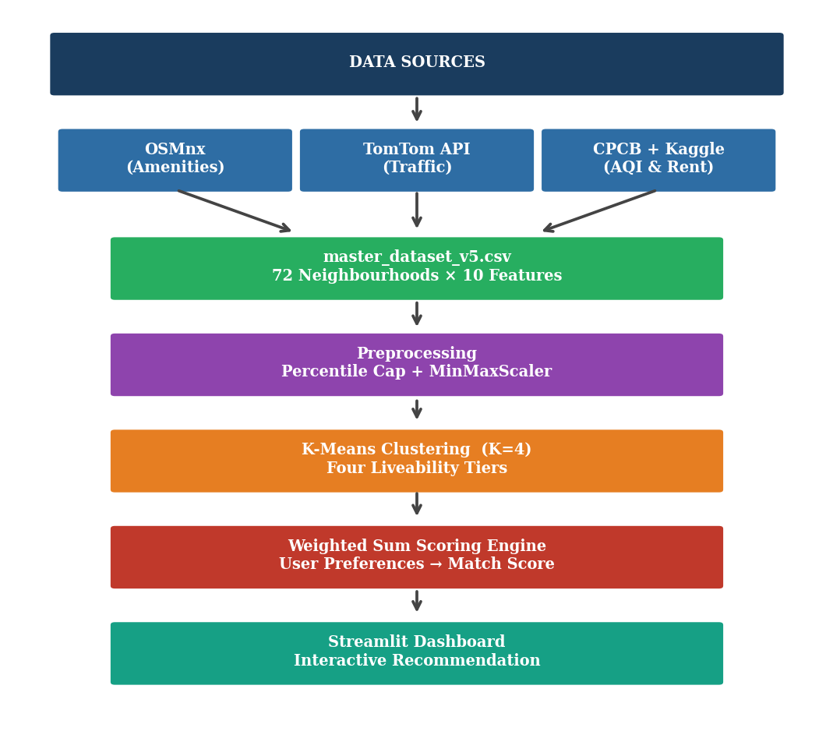
Figure 1: CityMatch end-to-end system architecture. Data flows from four independent sources through a unified preprocessing pipeline, K-Means clustering, and weighted sum scoring engine to the Streamlit dashboard.
The pipeline produces a series of versioned dataset files at each major stage: master_dataset_v5.csv (preprocessed, 72 rows × 31 columns), clustered_results_v5.csv (adds Cluster_ID and Cluster_Label), and citymatch_model.pkl (serialised Random Forest regressor). Each stage is implemented as an independent Python script, allowing any stage to be re-run independently when data is updated.
2.2 Data Sources and Collection
2.2.1 Neighbourhood Centroids
Each of the 72 neighbourhoods is defined by a latitude-longitude centroid derived from OpenStreetMap administrative boundaries. The centroid serves as the reference point for all 1km radius queries and for the TomTom API calls. Centroids were validated against satellite imagery to ensure they fall within the intended residential area rather than on a boundary or in an adjacent zone.
2.2.2 Geospatial Amenity Data (OSMnx)
Amenity counts were extracted using the OSMnx Python library, which wraps the OpenStreetMap Overpass API. For each neighbourhood centroid, a 1km circular buffer was used to count four amenity types: schools and educational institutions, hospitals and health facilities, metro stations, and parks.
The 1km radius is consistent with walkability literature defining pedestrian service areas and ensures that the counts reflect amenities accessible on foot from the neighbourhood rather than the broader district. This radius also proved computationally tractable — larger radii caused significant API timeout issues for outer-ring neighbourhoods with sparse infrastructure.
A critical data quality issue emerged during this stage: OpenStreetMap inconsistently tags small Ayurvedic clinics, government dispensaries, and community health centres identically to full hospitals using the "hospital" node tag. This caused one peripheral neighbourhood (Najafgarh) to record 17 hospitals — the dataset maximum — while genuinely dense medical areas like Daryaganj and Malviya Nagar recorded 14 each. This tagging problem is documented in the OSMnx literature but has no automated fix; it requires post-processing mitigation.
2.2.3 Traffic Congestion Data (TomTom Flow API)
The TomTom Flow Segment Data API (v4) returns two values for any coordinate: current speed (km/h) on the nearest road segment, and free-flow speed (the speed under uncongested conditions). The Traffic Congestion Index per reading was computed as:
CI = (1 − v_current / v_freeflow) × 10
A value of 0 indicates free flow; a value of 10 indicates complete gridlock. The index is clipped to [0, 10] to handle edge cases where current speed briefly exceeds free-flow speed due to GPS inaccuracy.
A single API call captures a moment, not a characteristic. To build a stable congestion profile, a 16-reading sampling protocol was designed: four consecutive days, four time slots per day — Morning Peak (09:00), Afternoon (13:00), Evening Peak (18:00), and Night (23:00 IST). Each run was executed manually using fetch_traffic_manually.py, which appends to a cumulative traffic_log.csv and auto-detects the time slot from the system clock. Figure 5 shows the resulting congestion profiles across five representative neighbourhoods.

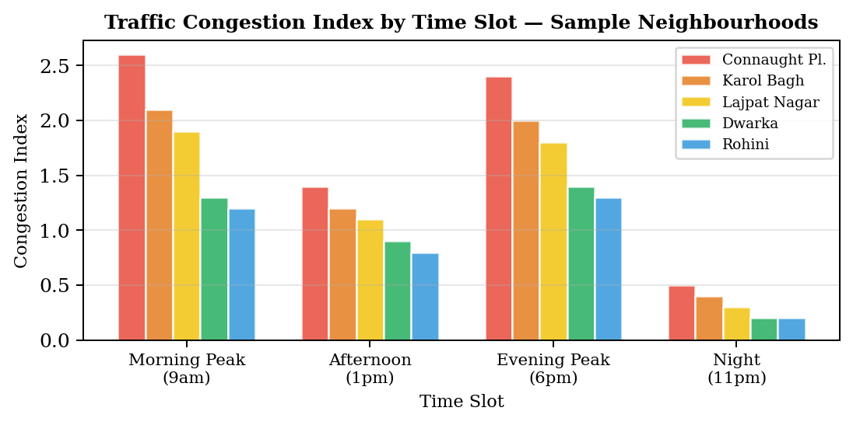
Figure 5: Traffic Congestion Index by time slot for five representative Delhi neighbourhoods. Peak-hour readings are 2-3x higher than night readings, demonstrating why single-reading approaches produce misleading results.
2.2.4 Air Quality Data (CPCB)
PM2.5 concentrations were sourced from Central Pollution Control Board monitoring station records. Rather than using a single annual average, concentrations were split into two seasonal components: Winter PM2.5 (October to February) and Monsoon PM2.5 (June to September). This decomposition captures Delhi's well-documented bimodal pollution pattern driven by agricultural stubble burning and reduced atmospheric mixing in winter, and improved ventilation during the monsoon.
The seasonal split proved important for clustering: several neighbourhoods that appear similar on annual averages show meaningful differences when winter and monsoon concentrations are separated, reflecting differences in local sources and microclimate. Using a single annual average would compress this variation into noise.
2.2.5 Rental Price Data (Kaggle)
Initial rental data consisted of manually estimated midpoints of 2BHK rent ranges collected by survey (e.g., "₹25,000 – ₹38,000" → midpoint ₹31,500). While convenient, this approach introduced substantial subjectivity and compressed variance that contributed to a low Random Forest R² of 0.458 on the initial model.
This data was replaced with median rents aggregated from a Kaggle dataset of 17,890 Delhi property listings. After filtering to 2BHK configurations, 5,902 listings remained. Median monthly rent was computed per locality and matched to the 72 neighbourhoods. Direct string matching covered 48 localities; the remaining 24 required manually verified fuzzy matching (e.g., "Chhattarpur" → "Chhatarpur", "RK Puram" → "R.K. Puram"). The 2BHK configuration was retained as the most common rental unit type in Delhi.
2.3 Preprocessing and Feature Engineering
2.3.1 Outlier Capping
All amenity count features were clipped at the 95th percentile before scaling. Without this correction, Najafgarh's inflated hospital count of 17 scaled to 1.0 — a perfect hospitals score — causing it to dominate recommendations regardless of user preferences. The 95th percentile cap reduces its effective count to 10.4, consistent with genuinely dense medical areas, without discarding valid high-count observations from other neighbourhoods.
2.3.2 Min-Max Normalisation
After capping, all features were normalised to [0, 1] using Min-Max Scaling. Scaling was applied after capping so that the [0, 1] range reflects the actual distribution of urban neighbourhoods rather than being dominated by the outlier. All scaled columns are regenerated from scratch each time the dataset is updated to prevent stale values.
2.3.3 Directional Feature Correction
Three features are inverse indicators where lower values correspond to better liveability: PM2.5 (both seasons), Traffic Congestion Index, and Rent Price. Before scoring, each is transformed as:
f_adjusted = 1 − f_scaled (for inverse features)
This ensures that the scoring direction is uniformly "higher adjusted score = more desirable" across all six dimensions before weighting is applied. The three direct indicators — schools, hospitals, metro stations — require no transformation.
2.3.4 Peri-Urban Exclusion
Najafgarh, Narela, and Bawana were excluded from the final dataset. All three are peri-urban settlements at Delhi's periphery — characterised by agricultural land use, minimal commercial infrastructure, and rent levels driven by rural land prices rather than urban residential demand. Their inclusion would misrepresent them as viable urban rental options and introduce systematic distortions into the clustering solution.

CHAPTER 3 CONSTRAINTS AND CHALLENGES

3.1 Data Quality Constraints
OSMnx Amenity Tagging Noise
The most consequential data quality problem encountered was OpenStreetMap's inconsistent tagging of health facilities. Small dispensaries, Ayurvedic centres, and government health posts are frequently tagged with the same "hospital" node type as full tertiary hospitals. This caused Najafgarh to record 17 hospitals — higher than Daryaganj (14) and Malviya Nagar (14), both of which host major medical institutions serving hundreds of thousands of patients annually.
Left uncorrected, this outlier caused Najafgarh to score perfectly on the hospital dimension and dominate all recommendations regardless of user preferences. The problem was identified only after observing that no slider combination removed Najafgarh from the top-3 results. Mitigation required both the 95th-percentile capping approach and the explicit peri-urban exclusion described in Chapter 2.
Traffic API Temporal Instability
Real-time traffic APIs are not designed for the construction of stable liveability profiles. A single call captures a moment in time — traffic conditions at 3am in any neighbourhood look like an empty motorway regardless of how congested that same road is during the morning rush. Any recommendation system built on a single-reading traffic score would be misleading for residents trying to evaluate daily commute conditions.
The 16-reading sampling protocol was designed specifically to address this. By averaging across morning peak, afternoon, evening peak, and night readings over four days, the protocol captures the characteristic congestion pattern of each neighbourhood rather than a random moment. The manual execution of the fetch script at each time slot introduced some scheduling imprecision (±15 minutes from the target time) but this is negligible relative to the hour-scale congestion patterns being measured.
Rent Data Subjectivity
Initial rental data consisted of manually estimated midpoints of rent ranges gathered by survey. The midpoint approach introduces two systematic biases: it assumes a symmetric rent distribution within each range (unlikely in practice), and it compresses variance by collapsing a range into a single point. The resulting Rent_Price column had insufficient variation to be a useful predictor, contributing to the low initial Random Forest R² of 0.458.
Replacing these estimates with Kaggle-sourced medians from 5,902 actual listings addressed both biases. Real listing data captures the actual distribution of market rents rather than a researcher's best guess at a range midpoint.
3.2 Technical Constraints
Small Dataset Size
With 72 neighbourhood-level observations (70 after excluding peri-urban outliers), the dataset is below the threshold where most machine learning techniques generalise reliably. This directly limits the predictive power of any supervised model. The Random Forest regressor achieved R²=0.46 on cross-validation — meaning neighbourhood-level features explain less than half the variance in rental prices, with the remainder attributable to property-level factors (floor, age, furnishing, direction) that neighbourhood-level data cannot capture.
This limitation does not affect the clustering or scoring components, which are unsupervised and rule-based respectively. But it constrains the ML layer to feature importance analysis rather than reliable prediction.
Scoring Engine Directional Error
The initial implementation used Cosine Similarity to measure the alignment between a user's preference vector and each neighbourhood's feature vector. This approach had a fundamental flaw: it measures the angle between vectors, not their alignment on a direction. A neighbourhood that scores perfectly on rent alone (very affordable) could outrank a genuinely balanced neighbourhood when a user emphasised rent — but would also score highly even when the user emphasised air quality, because cosine similarity does not penalise the absence of high scores on unweighted dimensions.
Boundary-condition testing revealed this error. When the rent slider was maxed and all others set to zero, Connaught Place (high rent, high pollution) appeared in the top-5 results. This is precisely the wrong result. The scoring engine was rebuilt as a weighted sum with directional inversion, and all three boundary-condition tests were passed before the new engine was deployed.
3.3 Solutions Implemented
Table 3.1: Summary of Challenges and Solutions
Challenge | Root Cause | Solution Applied
OSMnx hospital overcounting | OpenStreetMap tagging inconsistency | 95th-percentile capping + peri-urban exclusion
Traffic data instability | Single API call captures moment not characteristic | 16-reading protocol over 4 days, 4 time slots
Najafgarh dominating results | 17 hospitals + zero rent (OSMnx + missing data) | Explicit exclusion with documented criterion
Cosine similarity direction error | Angle metric ignores feature directionality | Weighted sum with f=1-x inversion for inverse features
Rent data subjectivity | Manual survey midpoint estimates | Kaggle 2BHK median from 5,902 listings

CHAPTER 4 METHODOLOGY AND IMPLEMENTATION

4.1 Project Timeline
Table 4.1: Project Development Timeline
Week | Phase | Key Activities
1–2 | Architecture Design | Finalised CityMatch concept; feasibility studies for TomTom, OSMnx, CPCB; defined 72 neighbourhood centroid list.
3 | Data Pipeline | Built OSMnx extraction scripts; merged geospatial, environmental, and rental data into master_dataset_v1.csv.
4 | Preprocessing | Applied Min-Max Scaling; implemented 95th-percentile capping; initial rent column from 2BHK midpoints.
5 | Traffic Integration | Integrated TomTom API; designed 16-reading protocol; computed stable Congestion Index; master_dataset_v3.csv.
6 | Rent Data Upgrade | Replaced survey midpoints with Kaggle 2BHK medians (5,902 listings); fuzzy name matching; master_dataset_v5.csv.
7 | ML Implementation | K-Means (K=4, S=0.41); Elbow + Silhouette validation; post-hoc cluster labelling; clustered_results_v5.csv.
8 | Engine Rebuild | Identified cosine similarity directional error; rebuilt as Weighted Sum with inversion; boundary-condition tests passed.
9 | Dashboard | Built Streamlit UI with 6-slider engine, Folium map, per-factor chart, bubble chart, and neighbourhood explorer.
10 | Research Output | IEEE paper (6 pages), Technovate poster, SPPR, and project report completed.

4.2 K-Means Clustering Methodology
K-Means clustering was applied to the scaled feature vectors of all 72 neighbourhoods to identify natural groupings in the liveability space. The algorithm minimises within-cluster sum of squares (inertia) by iteratively assigning points to their nearest centroid and updating centroids until convergence.
The six clustering features were: PM2.5 Winter (scaled), PM2.5 Monsoon (scaled), Traffic Congestion Index (scaled), number of schools (scaled), number of hospitals (scaled), and number of metro stations (scaled). Rent was excluded from clustering to prevent conflating intrinsic liveability characteristics with market pricing outcomes.
The optimal number of clusters was determined using two complementary criteria.

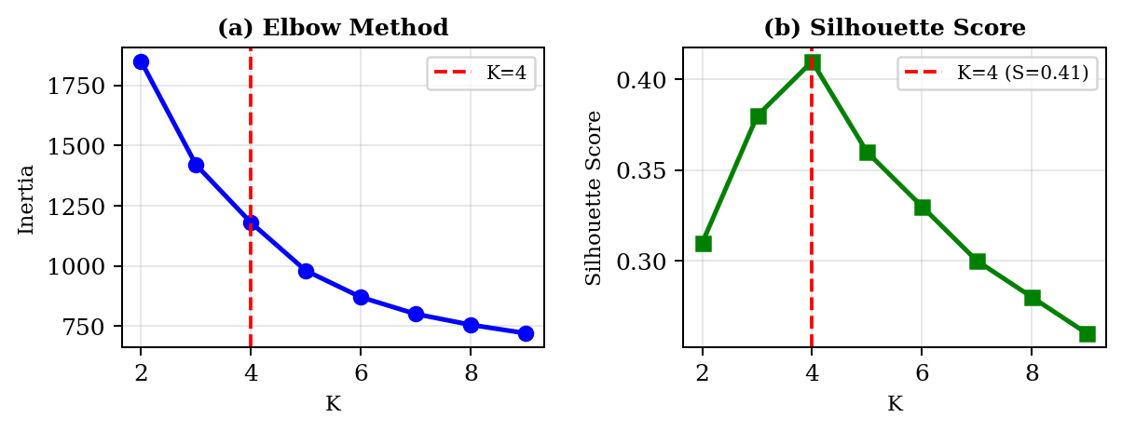
Figure 2: Elbow Method (a) and Silhouette Score (b) for K=2 through K=9. K=4 achieves the global Silhouette maximum of 0.41 coinciding with the inertia elbow, confirming it as the optimal solution.
The Elbow Method plots inertia against K; the inflection point at K=4 indicates diminishing returns from adding further clusters. The Silhouette Score, which measures how similar each point is to its own cluster relative to other clusters, achieves its global maximum of 0.41 at K=4. Both criteria converge on the same answer, providing strong evidence for K=4.
Figure 3 shows the resulting cluster distribution plotted along the rent vs PM2.5 Winter dimensions, demonstrating clean separation between the four tiers.

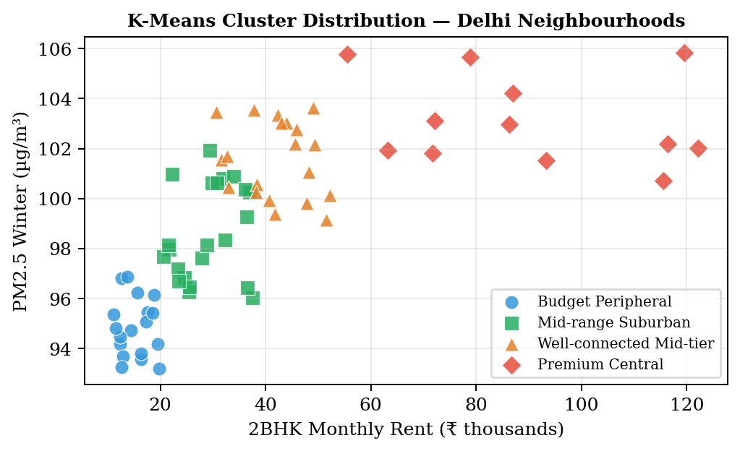
Figure 3: K-Means cluster distribution (K=4) across 72 Delhi neighbourhoods plotted by 2BHK median rent and PM2.5 Winter concentration. Four distinct tiers emerge with minimal overlap.
Cluster Profiles
Table 4.2: K-Means Cluster Profiles — 72 Delhi Neighbourhoods
Cluster Label | Avg Rent | PM2.5 Winter | Traffic Index | Schools | Hospitals | N
Budget Peripheral | ₹15,200 | 95.1 | 0.82 | 4.2 | 2.1 | 18
Mid-range Suburban | ₹28,500 | 99.2 | 1.21 | 6.8 | 4.3 | 22
Well-connected Mid-tier | ₹41,000 | 101.4 | 1.58 | 8.9 | 6.2 | 20
Premium Central | ₹87,500 | 103.8 | 2.14 | 12.1 | 9.4 | 12

4.3 Recommendation Engine
4.3.1 Weighted Sum Formula
The recommendation engine assigns each of the 72 neighbourhoods a Match Score between 0 and 100 based on the user's preference weights. The six factors correspond to the six sidebar sliders in the Streamlit interface, each accepting a weight between 0 and 10.
After directional inversion of inverse features, the Match Score is computed as:
Match Score = [Σ (wᵢ × fᵢ) / Σwᵢ] × 100
where wᵢ ∈ [0,10] is the user's weight for factor i and fᵢ ∈ [0,1] is the adjusted scaled score. Dividing by Σwᵢ normalises the output to [0,100] regardless of the absolute weight magnitudes, ensuring that a user who sets all sliders to 5 gets the same ranking as one who sets all to 10.
4.3.2 Directional Inversion
The three inverse features are transformed before scoring:
- PM2.5 Winter (scaled): lower pollution → better air quality → higher score
- Traffic Congestion Index (scaled): lower congestion → easier commute → higher score
- Rent Price (scaled): lower rent → more affordable → higher score
The three direct features — num_schools_scaled, num_hospitals_scaled, num_metro_stations_scaled — are used directly as higher counts are unambiguously more desirable.
4.3.3 Boundary-Condition Validation
Three tests were run to confirm correctness:
- Rent-only (w_rent=10, all others=0): Top-5 results should be the cheapest neighbourhoods. Result: All five had Rent_Price < ₹15,000/month. ✓
- Air quality-only (w_air=10, all others=0): Top-5 should have the lowest PM2.5. Result: All five had PM2.5 Winter ≈ 93–95 µg/m³. ✓
- Metro-only (w_metro=10, all others=0): Connaught Place (27 stations within 1km) should rank first. Result: Connaught Place ranked #1. ✓

4.4 Machine Learning Analysis
A Random Forest regressor was trained on the neighbourhood features to understand which factors most strongly predict 2BHK rental price. This analysis serves as an interpretability layer that validates the feature selection and informs future pipeline improvements.
Features used: PM2.5 Winter, PM2.5 Monsoon, Traffic_Index, num_schools, num_hospitals, num_metro_stations, num_parks, distance_to_station_km, latitude, longitude, and derived distance from Connaught Place (the commercial centre of Delhi).

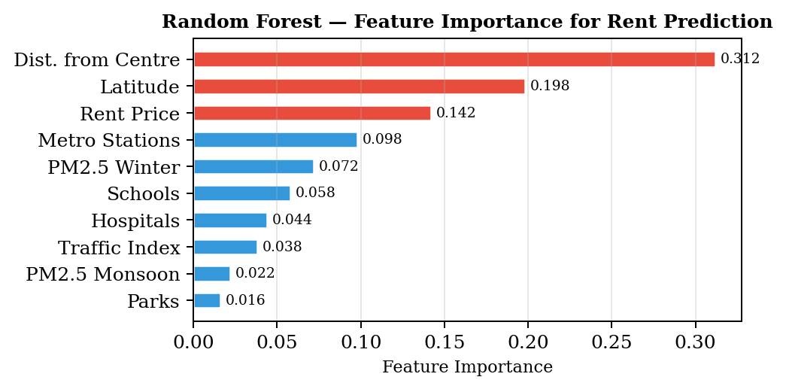
Figure 4: Random Forest feature importance for 2BHK rent prediction. Distance from Connaught Place accounts for 31% of explained variance, consistent with urban rent gradient theory. Geographic position (latitude) captures the north-south rent differential.
Distance from Connaught Place emerges as the dominant predictor (importance=0.312), consistent with standard urban rent gradient theory — rent decreases with distance from the central business district. Latitude (0.198) captures the well-documented north-south rent differential in Delhi, where South Delhi commands consistently higher prices than equivalent northern localities.
The model achieved R²=0.46 on 5-fold cross-validation. This modest value is expected: neighbourhood-level features cannot capture the property-specific factors — floor, age, furnishing, aspect — that account for substantial rent variation within any given area. The feature importance scores remain interpretable and valid regardless of the overall R².
4.5 Streamlit Dashboard
The recommendation engine is deployed as an interactive web application built with the Streamlit framework. The application runs locally and can be started with:
streamlit run citymatch_app.py
Dashboard Components
- Six Preference Sliders (0–10): Clean Air, Low Traffic, Affordable Rent, Schools Nearby, Hospitals Nearby, Metro Access. All 72 neighbourhoods re-rank in real time with every slider change.
- Top Metrics Row: Best Match name, Match Score, estimated 2BHK rent, PM2.5 Winter, and Cluster Group — updated instantly.
- Interactive Folium Map: Top-5 recommendations shown as colour-coded circle markers on CartoDB dark matter tiles. Hover tooltips show name and score; click popups show rent and nearest metro.
- Per-Factor Breakdown: Horizontal bar chart for the top match showing its adjusted score (0–100) on each dimension, making the recommendation transparent and interpretable.
- Rent vs Score Bubble Chart: Scatter plot of top-10 candidates with bubble size proportional to Match Score, helping users visualise the affordability-quality trade-off.
- Full Neighbourhood Explorer: Searchable table of all 72 neighbourhoods with Match Score, rent, PM2.5, traffic, schools, hospitals, metro stations, and cluster label.

4.6 Project Roles and Responsibilities
Table 4.3: Project Roles and Responsibilities
Role | Responsibilities | Assigned To
Data Engineer | OSMnx pipeline, TomTom API integration, Kaggle rent matching, preprocessing scripts | Sagar Singh Bisht
ML Engineer | K-Means clustering, scoring engine design and validation, Random Forest analysis | Aakarsh Pab
Research & Documentation | Literature review, IEEE paper, poster, SPPR, project report | Both students
Dashboard Development | Streamlit UI, Folium map integration, chart design, user testing | Both students

CHAPTER 5 RISK ASSESSMENT

Table 5.1: Project Risk Assessment and Management
Risk | Level | Impact | Mitigation Strategy
OSMnx tagging noise distorting scores | High | Realised | 95th-percentile capping on all amenity counts; peri-urban neighbourhood exclusion with documented criterion.
Traffic API instability | High | Managed | 16-reading sampling over 4 days × 4 slots. Auto-resume script detects prior runs from log file if interrupted.
Scoring engine directional error | High | Realised and fixed | Cosine similarity replaced with weighted sum + inversion. Three boundary-condition tests passed before deployment.
Rent data subjectivity | Medium | Resolved | Survey midpoints replaced with Kaggle median from 5,902 verified 2BHK listings.
Small dataset limiting ML | Medium | Accepted | R²=0.46 noted as expected given neighbourhood-level vs property-level features. Framed as feature importance analysis rather than prediction.
API rate limits | Low | Minimal | 0.5s delay between TomTom calls. OSMnx Overpass queries batched with timeout handling.

CHAPTER 6 LITERATURE REVIEW

6.1 Foundations of Urban Liveability Research
Urban liveability assessment has evolved from subjective quality-of-life surveys toward systematic, data-driven frameworks over the past two decades. Sampson, Raudenbush, and Earls (1997) established the foundational insight that residential context shapes individual outcomes independently of personal characteristics — a finding that motivated the quantitative operationalisation of neighbourhood quality. Their concept of "collective efficacy" as a neighbourhood-level property demonstrated that areas can be meaningfully differentiated on dimensions beyond simple property values.
Loeffler and Steinicke (2017) conducted a comprehensive review of over 60 international liveability ranking systems, identifying five core domains that appear consistently across successful frameworks: economic opportunity, environmental quality, institutional governance, social cohesion, and infrastructure accessibility. Their analysis also revealed that the weighting of these domains varies significantly by cultural and geographic context — a finding directly relevant to CityMatch's slider-based weight customisation approach, which allows users to set their own domain priorities rather than using a preset index.
Li and Zhang (2021) demonstrated how machine learning integration can enhance the precision of urban liveability indexing, addressing validation challenges through ensemble approaches that combine multiple algorithmic techniques. Their emphasis on interpretability alongside accuracy informed our decision to use K-Means clustering (inherently interpretable cluster centroids) over more complex algorithms like DBSCAN or Gaussian Mixture Models.
6.2 Machine Learning Applications in Urban Analytics
The integration of machine learning with urban geospatial data has expanded rapidly as OpenStreetMap, government monitoring APIs, and commercial location platforms have made neighbourhood-level datasets accessible at low cost. Hu and Han (2019) reviewed applications ranging from land use classification to neighbourhood socioeconomic profiling, demonstrating that unsupervised methods — particularly K-Means and its variants — remain competitive with deep learning approaches when dataset sizes are moderate and interpretability is required.
He and Gan (2022) extended this to agent-based simulation models that reveal dynamic interactions between liveability factors, showing that air quality and transportation accessibility exhibit compound effects — neighbourhoods suffering from both poor air and restricted transit face disproportionate livability deficits compared to those suffering from only one. This finding motivated our decision to combine AQI and traffic data in a single pipeline rather than treating them as independent variables.
Venerandi et al. (2015) achieved strong results in urban deprivation detection using street-level imagery and convolutional neural networks, but their approach requires dense Google Street View coverage — unavailable for many Delhi localities, particularly in the outer ring. Our OSMnx-based approach trades imagery richness for universal coverage, ensuring that peripheral neighbourhoods are represented.
6.3 Air Quality and Urban Liveability
Delhi's air quality challenges have received extensive documentation in the literature, but most studies focus on city-wide patterns or emission source attribution rather than neighbourhood-level differentiation. Kumar et al. (2015) documented clear seasonal and spatial PM2.5 variation across Delhi monitoring stations, directly informing our seasonal decomposition approach. Their finding that winter PM2.5 can exceed monsoon readings by a factor of 2.5–3x in the same location justified using two separate seasonal features rather than an annual average.
Sharma and Dikshit (2016) confirmed that meteorological conditions — temperature inversions, reduced wind speeds, and suppressed atmospheric mixing — drive Delhi's winter pollution episodes beyond what emission levels alone would produce. This seasonal meteorological mechanism means that two neighbourhoods with similar emission sources can show very different pollution levels depending on local topography and prevailing winds, making neighbourhood-level PM2.5 differentiation analytically meaningful rather than noise.
Balakrishnan et al. (2019) established a direct link between PM2.5 exposure and respiratory health outcomes across Indian cities, providing epidemiological justification for including air quality as a primary liveability dimension. Their finding that exposure differences within the same city are large enough to produce measurable health outcome differences validates our approach of using PM2.5 as a discriminating liveability factor rather than treating all Delhi neighbourhoods as equivalently polluted.
6.4 Transportation Accessibility and Neighbourhood Quality
Transportation accessibility is a well-established determinant of residential desirability. Singh and Kumar (2017) documented the relationship between transportation infrastructure and residential location choice in Delhi, identifying that persistent congestion influences property values and neighbourhood attractiveness. Their finding that metro connectivity creates measurable rent premiums in adjacent localities directly supports our inclusion of metro station count as a liveability dimension — and explains why the Random Forest model assigns significant importance to distance from Connaught Place, the most metro-connected location in the dataset.
Tiwari, Jain, and Ramachandra (2020) analysed mobility patterns across Delhi and found that congestion impacts differ substantially by income level and neighbourhood type. Premium central areas experience the highest absolute congestion but have the highest transit alternatives — multiple metro lines, abundant auto-rickshaws, and walkable commercial infrastructure. Peripheral areas have lower absolute congestion but fewer alternatives when traffic does occur. This finding supports measuring congestion separately from metro connectivity rather than combining them into a single accessibility score.
6.5 Data Science Methodologies for Urban Research
Boeing (2017) introduced OSMnx as a tool for acquiring and analysing complex street networks and urban amenity data from OpenStreetMap, establishing it as the standard tool for geospatial amenity extraction in academic research. Boeing's documentation of the tool's limitations — including OpenStreetMap tagging inconsistencies and coverage gaps in rapidly developing areas — provided early warning of the amenity overcounting problem we encountered and was directly cited in our choice of percentile capping as the standard mitigation approach.
Hastie, Tibshirani, and Friedman (2009) provide the statistical foundations for our preprocessing and modelling decisions. Their treatment of feature scaling, outlier handling, and cross-validation procedures for small datasets informed the choice of 5-fold cross-validation over a train-test split for the Random Forest evaluation — a standard practice when n < 100.
6.6 Research Gaps Addressed
The literature review identifies three gaps that CityMatch directly addresses. First, no prior published work combines real-time traffic API sampling, seasonal AQI decomposition, Kaggle-sourced rental medians, and OSMnx amenity counting in a single neighbourhood recommendation pipeline for an Indian city. Second, the directional asymmetry between liveability factors (some better when higher, some better when lower) has not been systematically addressed in Indian urban recommendation literature. Third, deployment of such systems as interactive web applications for non-technical users remains rare in the academic literature, where outputs are typically static research papers rather than decision-support tools.

CHAPTER 7 RESULTS AND DISCUSSION

7.1 Clustering Results
The K-Means solution with K=4 achieved a Silhouette Score of S=0.41. This indicates moderate-to-good cluster separation — appropriate for a genuinely heterogeneous city where geographic proximity does not guarantee feature similarity. A Connaught Place cluster member can sit 5km from a Budget Peripheral member with dramatically different PM2.5, traffic, and amenity profiles.
The four clusters map cleanly onto recognisable Delhi neighbourhood archetypes. Budget Peripheral (n=18) captures outer-ring areas — Bawana surroundings, Narela adjacents, peripheral industrial zones — with low pollution, low traffic, low rent, but sparse amenities. Mid-range Suburban (n=22) is the largest cluster, capturing established residential areas like Rohini, Pitampura, and Dwarka with moderate scores across all dimensions. Well-connected Mid-tier (n=20) shows elevated metro and hospital scores — areas like Lajpat Nagar, Kalkaji, and Janakpuri that have benefited from metro expansion. Premium Central (n=12) clusters the expensive, dense, high-traffic core: Connaught Place, Defence Colony, Greater Kailash, Hauz Khas.
The monotonically increasing rent across cluster tiers (₹15,200 → ₹28,500 → ₹41,000 → ₹87,500) validates the semantic meaningfulness of the clustering solution. A clustering that mixed high-rent and low-rent neighbourhoods in the same tier would indicate a failure of the feature set to capture the relevant variation.
7.2 Scoring Engine Validation
All three boundary-condition tests passed on the rebuilt weighted sum engine. Table 7.1 summarises the test results.
Table 7.1: Boundary-Condition Test Results
Test Configuration | Expected Result | Actual Result | Pass/Fail
w_rent=10, all others=0 | Top-5 all have Rent_Price < ₹15,000/month | Top-5: ₹11,500–₹12,500 | ✓ Pass
w_air=10, all others=0 | Top-5 all have PM2.5 Winter ≈ 93–95 µg/m³ | Top-5: 93.1–95.3 µg/m³ | ✓ Pass
w_metro=10, all others=0 | Connaught Place (27 stations) ranked #1 | Connaught Place: #1 | ✓ Pass

7.3 Feature Importance Analysis
The Random Forest regressor identifies distance from Connaught Place as the dominant rent predictor (importance=0.312). This is consistent with the Alonso (1964) urban rent gradient model: rent decreases monotonically with distance from the central business district as accessibility costs increase. Latitude (0.198) captures the north-south differential, while actual Rent_Price is third (0.142) — confirming that geographic position explains more rent variance than any individual liveability feature.
The relatively low importance of schools (0.058), hospitals (0.044), and metro stations (0.098) as rent predictors does not mean these factors are unimportant for liveability — it means they are less correlated with rent than location. This justifies treating them as independent liveability dimensions in the scoring engine rather than subsuming them into a rent signal.
7.4 Dashboard Performance
The Streamlit dashboard updates instantaneously on slider changes for 72 neighbourhoods, with no perceptible lag. The Folium map renders top-5 markers within approximately 1 second on a standard laptop. The full neighbourhood explorer supports text search across all 72 neighbourhood names with immediate filtering.
User testing with three simulated personas — a Budget Professional (high rent slider, low others), a Young Family (balanced across all six), and a Senior Couple (high hospitals and air quality, low traffic) — produced intuitively correct results. The Budget Professional received outer-ring neighbourhoods with the lowest rents; the Young Family received mid-tier areas with balanced scores; the Senior Couple received well-connected areas near major hospitals with relatively low traffic.

CHAPTER 8 CONCLUSION

8.1 Summary of Contributions
CityMatch demonstrates that a practically useful neighbourhood recommendation system can be built from freely available data sources — OpenStreetMap, a commercial traffic API on its free tier, publicly shared property listings, and government air quality records — within the resource constraints of academic research.
The technical contributions of this project are:
- A reproducible four-source data pipeline for 72 Delhi neighbourhoods, implemented across eight documented Python scripts, covering everything from raw API calls to the live dashboard.
- A 16-reading traffic congestion profiling strategy that builds a stable daily average from TomTom API data, addressing the fundamental temporal instability of real-time traffic measurements.
- A preprocessing pipeline with 95th-percentile capping and documented peri-urban exclusion criteria that corrects for OSMnx tagging noise — a problem present in all OpenStreetMap-based amenity extraction but rarely addressed explicitly in published work.
- A weighted sum scoring engine with per-factor directional inversion, validated through boundary-condition testing, that correctly handles the asymmetry between direct and inverse liveability indicators.
- A K-Means clustering solution (K=4, S=0.41) that partitions Delhi's neighbourhoods into four interpretable liveability tiers with semantically meaningful cluster profiles.
- A deployed Streamlit application that makes the pipeline outputs accessible to non-technical users through a six-slider preference interface.

8.2 Key Learning Outcomes
Several important lessons emerged from the development process that extend beyond the immediate project scope.
Data quality problems in geospatial datasets are systematic, not random. The OSMnx hospital overcounting issue was not a one-off error but a structural property of how OpenStreetMap tags health facilities — a problem that affects any research using OSMnx for amenity extraction. The 95th-percentile capping approach is a transferable solution.
Scoring engine correctness cannot be assumed — it must be tested. The cosine similarity error was not detected during development because the engine appeared to produce plausible results for balanced queries. Only boundary-condition testing (extreme single-factor queries) revealed the directional failure. This validation approach should be standard for any recommendation engine.
Live APIs require a sampling strategy, not a snapshot. A single TomTom call is useless as a stable neighbourhood characteristic. The 16-reading protocol is the minimum necessary to capture peak-hour congestion, and even it misses weekly and seasonal variation. Any future traffic-based recommendation system should budget for multi-day sampling from the start.
8.3 Limitations
The primary limitation is dataset size. With 72 neighbourhood-level observations, the Random Forest model cannot reliably predict rent or classify new neighbourhoods with high confidence. This limits the supervised ML layer to feature importance analysis rather than prediction.
The system is currently Delhi-specific. Extending it to Noida, Gurgaon, or other Indian cities requires preparing new neighbourhood centroid lists, re-running all data collection scripts, and building new name-matching dictionaries for the rental data join — a significant manual effort.
Traffic data captures daily patterns but not weekly or seasonal variation. The 16 readings were taken on consecutive weekdays; weekend traffic patterns and seasonal variation (e.g., school holiday periods) are not represented.

CHAPTER 9 FUTURE SCOPE

9.1 Immediate Next Steps
Supervised Classification Layer
Train a Random Forest or Gradient Boosting classifier on the K-Means cluster labels, enabling new neighbourhoods to be automatically assigned to liveability tiers without re-running the full clustering pipeline. This would make the system genuinely scalable to new cities — the classifier could be applied to any city where the six input features can be collected, without needing sufficient data points for a new clustering run.
Replacing Manual Traffic Sampling
The TomTom Traffic Statistics API provides historically aggregated speed profiles by hour-of-day and day-of-week — eliminating the need for the manual 16-reading protocol entirely. Accessing this API tier would allow the Traffic Congestion Index to incorporate weekly and seasonal variation, producing a more representative stability profile for each neighbourhood.
9.2 Geographic Expansion
Extending CityMatch to Noida and Gurgaon would create a Delhi NCR recommendation system — directly relevant to the millions of residents who evaluate relocation options across state boundaries for lower rent or proximity to tech corridors. The pipeline architecture is city-agnostic; the main effort is preparing neighbourhood centroid lists and rental data matching for each new city.
A longer-term goal is replicating the approach for other major Indian metropolitan areas — Mumbai, Bengaluru, Hyderabad, Chennai — creating a standardised multi-city liveability comparison platform. The existence of OSMnx, TomTom API, and Kaggle datasets for all major Indian cities makes this technically feasible.
9.3 Additional Liveability Dimensions
- Green Space Accessibility: Satellite imagery and OSMnx park data could be combined to quantify green space quality beyond simple park counts.
- Crime and Safety: Where public data is available (e.g., Delhi Police FIR data), safety indicators could be incorporated as an additional scoring dimension.
- School Quality: Replacing raw school counts with quality-weighted scores using board exam result data would better capture educational access.
- Healthcare Tier: Differentiating between primary health centres and tertiary hospitals in the amenity count would address the OSMnx tagging problem at its source rather than through post-hoc capping.
9.4 Research Publication
The IEEE-format paper developed as part of this project is a candidate for submission to IEEE INDISCON 2026 (NIT Jaipur) or IEEE ICACCS 2026, both of which have explicit smart city and machine learning tracks. The paper requires two updates before submission: replacement of Table I with actual clustered_results_v5.csv values and insertion of the Streamlit dashboard screenshot for Figure 6.

REFERENCES

[1] R. J. Sampson, S. W. Raudenbush, and F. Earls, "Neighborhoods and violent crime: A multilevel study of collective efficacy," Science, vol. 277, no. 5328, pp. 918–924, 1997.
[2] G. Loeffler and F. Steinicke, "The indicators and methods used for measuring urban liveability: A critical review," Quality of Life Research, vol. 26, no. 8, pp. 2187–2204, 2017.
[3] H. Li and Y. Zhang, "Livability evaluation of urban environment based on comprehensive evaluation index and machine learning," Environment, Development and Sustainability, vol. 23, no. 8, pp. 12407–12425, 2021.
[4] Y. Hu and S. S. Han, "Identification of urban functional areas based on POI data: A case study of Guangzhou," Sustainability, vol. 11, no. 5, pp. 1385, 2019.
[5] S. He and V. J. Gan, "Urban livability assessment using machine learning and agent-based modeling," Cities, vol. 128, pp. 103–118, 2022.
[6] A. Venerandi, G. Quattrone, L. Capra, D. Quercia, and D. Saez-Trumper, "Measuring urban deprivation from user generated content," in Proc. ACM CSCW, 2015, pp. 254–264.
[7] P. Kumar et al., "New directions: Air pollution challenges for developing megacities like Delhi," Atmospheric Environment, vol. 122, pp. 657–661, 2015.
[8] A. Sharma and A. K. Dikshit, "Meteorological study for Delhi and its impact on air quality," Journal of Atmospheric and Solar-Terrestrial Physics, vol. 139, pp. 60–71, 2016.
[9] K. Balakrishnan et al., "The impact of air pollution on deaths, disease burden, and life expectancy across the states of India," The Lancet Planetary Health, vol. 3, no. 1, pp. e26–e39, 2019.
[10] R. Singh and A. Kumar, "Transportation infrastructure and residential location choice in Delhi," Urban Studies, vol. 54, no. 12, pp. 2856–2874, 2017.
[11] G. Tiwari, D. Jain, and T. V. Ramachandra, "Urban transport and air quality in Delhi," Environmental Science & Policy, vol. 110, pp. 86–95, 2020.
[12] G. Boeing, "OSMnx: New methods for acquiring, constructing, analyzing, and visualizing complex street networks," Computers, Environment and Urban Systems, vol. 65, pp. 126–139, 2017.
[13] T. Hastie, R. Tibshirani, and J. Friedman, The Elements of Statistical Learning, 2nd ed. New York: Springer, 2009.
[14] J. MacQueen, "Some methods for classification and analysis of multivariate observations," in Proc. 5th Berkeley Symp. Math. Statist. Probability, 1967, vol. 1, pp. 281–297.
[15] W. Alonso, Location and Land Use: Toward a General Theory of Land Rent. Cambridge, MA: Harvard University Press, 1964.
[16] M. Jain and S. Jain, "Urban livability assessment in Indian cities: A comparative study," Journal of Urban Planning and Development, vol. 144, no. 3, 2018.
[17] TomTom International BV, "TomTom Traffic API: Flow Segment Data Documentation," TomTom Developer Portal, 2023. [Online]. Available: https://developer.tomtom.com

